|  |  |
| --- | --- |
| CV Template for python developers | Job Search advise  Have your CV and LinkedIn profile and CV in order before applying/opening yourself to new opportunities. Make sure all the information is accurate as there is no point in adding technologies to your CV you are not skilled in.  Rory Lawlor  Senior IT Recruitment Consultant |

**City: Dublin, Ireland**

**Email:** [**Random@gmail.com**](mailto:Random@gmail.com)

**Github: Random.org**

**Tel: +353 8000000000**

**Professional Profile**

A results-focused Software Developer with X years of experience in web development and system programming, relational databases and developing robust code for high-volume businesses. Excels in every stage of the life cycle of software development, including design creation, coding, debugging, testing, and maintenance.

**Technical skills include:**

* **Operating Systems:** Linux. macOS, Windows,
* **Programming / Scripting Languages:** Python, Perl, Bash, and Ruby
* **RDBMS/Web servers/Application Servers:** Postgres, Microsoft SQL Server, MongoDB, Cassandra, Redis, and Apache
* **Frameworks:** Django, Flask, Tornado, Twisted, AIOHTTP, Gorilla
* **IaaS/PaaS:** Amazon AWS(EC2, EBS, S3), Azure, GCP, Docker, Kubernetes
* **Other skills:** Network Administration, Linux System Administration

**Education and Qualifications**

Computer Science Degree

Result: Honours

**Career Summary**

**2019 - Present**

* **Point 1**
* **Point 2**
* **Point 3**

**Technologies Used:** Python 2, Python 3, Flask, Django, Docker, AWS, Kubernetes, and MongoDB

**2018 - 2019**

**Software Engineer,**

* **Point 1**
* **Point 2**
* **Point 3**

**Technologies Used:** Python 3, Flask, MS SQL Server, pytest, pycov, flake8, redis cluster, MongoDB, nginx, SQLAlchemy . Go, Gorilla.

**February 2017 - February 2018**

**Software Engineer,**

* **Point 1**
* **Point 2**
* **Point 3**

**Technologies Used:** Python 2, Python 3, unittest, Tornado, Flask, AWS (EC2, S3, DynamoDB), etcd, Puppet, Docker, Cassandra, haproxy, memcached,   
VMware vSphere, ESXi, cProfile

**July 2015 - February 2017**

**Software Developer**

* **Point1**
* **Point2**
* **Point3**

**Technologies Used:** Python 2, Python 3, Tornado, asyncio, AngularJS, Mondrian 4,   
Pentaho BI, RabbitMQ, PostgreSQL, SAML, Zabbix, Docker, nginx,   
SQLAlchemy, Alembic

**January 2014 - July 2015**

**Software Engineer,**

* **Point 1**
* **Point 2**
* **Point 3**

**Technologies Used:** Python, Django, Redis, MySQL,   
RabbitMQ, Celery, AstriskPBX, ExtJs

**November 2011 - January 2014**

**Software Engineer**

* **Point 1**
* **Point 2**
* **Point 3**

**Technologies Used:** Python, Django, JavaScript, Backbone.js, HTML/CSS, Oracle RDBMS

**Hobbies and Interests**

* Reading and writing
* Sports
* Keen on music and love to go to gigs.

**Reference Available on Request**

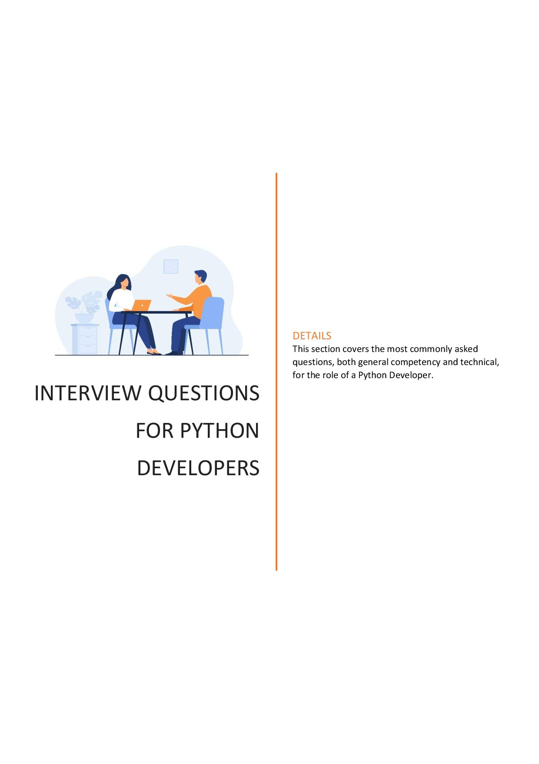

**Interview questions – General Competency**

* Tell be about a time you had an argument with a superior and what was the outcome?
* How do you maintain a good working relationship with a colleague?
* In your opinion, what makes a good leader?
* Tell me about a big decision you recently made and what was the outcome?
* Tell me about a time you used your communication skills to improve a situation?
* How do you deal with adversity?
* What’s the most challenging situation you have been in and how did you overcome it?
* Do you feel you are influential? How have you used your influence around conflict and what was the outcome?
* Tell me about a time you solved a problem in a creative way?
* Tell me about a time you achieved success against the odds?
* What’s your proudest moment in a professional setting?

***How to answer the questions – STAR – Situation, Task, Action and Result***

**Interview Questions- Technical Questions**

* What are the key characteristics of Python?
* What are negative indices?
* What is a recursion?
* How is memory stored in Python?
* What is a lambda function?
* How can you generate random numbers in Python?
* What are negative indexes and why are they used?
* How is multithreading attained in Python?
* How are classes created in Python?
* Write a program in Python to check if a number is prime.
* Is Django better than flask?
* Is Flask better than Django?
* Discuss the Python frameworks you have worked with?
* What is the map function in Python?